**Private Groups that have sharing enabled (FLOW)**

API Permissions needed: **Group.Read.All and Site.Read.All**

**And Flow need to run as a SharePoint Administrator**

# The FLOW:

Import the Flow packed and change the values:

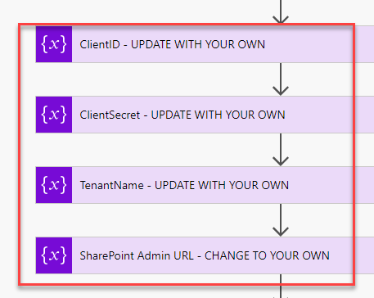

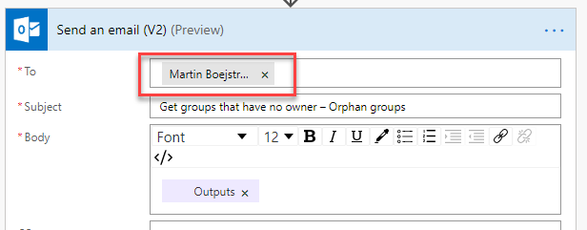

# Sample Result:

